**Ch. 10 11.) if you accept one you can’t accept the other.**

**7.)**

**FI 393**

**Chapter 5—Interest Rates and Bond Valuation**

**Notes Outline**

1. What is a bond?

***fixed income investment in which an investor loans money to an entity (typically corporate or governmental) which borrows the funds for a defined period of time at a variable or fixed interest rate.***

1. Borrowers include:
2. ***Companies***
   1. Corporate Bonds
3. U.S. Federal Government
   1. T-bills, T-notes, T-bonds
4. State/Local Govt
   1. Municipal Bonds
5. Bonds 🡪 __***Interest-Only***___ loans
   * __***Interest***__ is paid each period (usually semi-annually)
   * ___***Principal***_ is repaid at the end of the loan

Suppose Apple Inc. wants to borrow $1000 for 10 years.

* The interest rate on similar corporate debt issues is 3.45%.
* Thus, Apple will pay __***0.0345 X 1000 = 34.50***___ in interest every year for 10 years.
* At the end of the 10 years, Apple will repay the __***1,000***__.

1. What are the four characteristics of a bond? Do these factors change over time?
2. ***Par (face) Value (usually 1000)***
3. ***Coupon Interest Rt***
4. ***Coupon Payment***
5. ***Maturity Date (usually 10-20 yrs)***

*Note: These factors do not change

*Note on Par Value: Bonds are priced per dollar of face value. We use $100 or $1000 as a convenience.

1. What is the Yield to Maturity (YTM) of a bond? Does the YTM to change over time?

***The required market interest rt on the bond. Does change over time w/ market interest rt.***

1. REMEMBER: The coupon rate of an ordinary bond ***NEVER Changes*** .
2. Par value:
   * Face amount
   * Repaid __***@ Maturity***__.
   * Assume $1,000 for corporate bonds.
3. Coupon interest rate:
   * Stated interest rate
   * Usually = _***YTM***_ at issue
   * Multiply by par value to get total coupon payments made in a year
$$Coupon Payment=\frac{Face Amount*Coupon Interest Rate}{\# of Coupon Payments Per Year}$$

4. Maturity:
   * Years until ___***the Par Value on the bond must be paid***__
5. Yield to Maturity (YTM):
   * The _***market required rt return*** _for bonds of similar risk and maturity.
   * The __***Discount***__ rate used to value a bond.
   * Return if bond is held until ___***Maturity***_.
   * Usually, YTM = coupon rate at issue.
   * Quoted as an ________.
6. In our example with Apple, what are the par value, coupon interest rate, coupon payment and maturity?
   * Par (face) value = _**1,000**__
   * Coupon interest rate = _**3.45%**__
   * Coupon payment = ___**0.00345 x 1000 = 34.50**_*if annually divide by 2___
   * Maturity = __**10 yrs**_
7. The primary principle of bond valuation: value of financial securities = PV of expected future cash flows. Bond value is, therefore, determined by:

***The present value of the coupon payments and par value. That is : PV of an annuity, PV of a lump sum, or Bond Value = PV + PV***

1. Interest rates are ***Inversely*** related to present (i.e., bond) values.
   * That is, present values ***Fall*** as interest rates __***Increase***_.
   * Thus, bond values ***Fall*** as interest rates ___***Increase***__.
2. To determine the value of a bond at a particular point in time, we need to know:

* The # of periods remaining until **Maturity**
* The **Face Value**
* **Coupon**
* The market interest rt for bonds w/ similar features (**YTM)**

Given this information, we can calculate ***The PV of the cash flows as an est of the bonds current market value (price)***

1. The Ordinary Bond-Pricing Equation is:

$$Bond Value=C \left[\frac{1-\frac{1}{{(1+r)}^{T}}}{r}\right]+\frac{F}{{(1+r)}^{T}}$$

What is **C**?

***Coupon Payment***

What is **r**? What happens to Bond Value as **r** increases?

***YTM - Decreases***

What is **F**?

***Face Value***

What is **T**?

***Time of Maturity***

This formula has **two** parts. The first part, which deals with the bond’s coupon payment, is the:

***Present Value of an annuity*** .

The second part, which deals with the bond’s face value is the:

***PV of a lump sum***.

1. In the semi-annual case, the formula for the PV for a cash flow received at time T is:



1. Texas Instruments BA-II Plus:
   * **N**  = number of periods to maturity
   * **I/Y** = period interest rate = YTM (if annual coupon payments)
   * **PV** = present value = bond price
   * **PMT** = coupon payment
   * **FV** = future value = face value = par value
2. Valuing a Discount Bond with Annual Coupons
   * The **par value** of the bond is ***1000***
   * Assume **coupon payments** are made ***Annual***
   * Because the **coupon rate** is 10%, the 100 coupon payment is: _***1000***______.
   * Maturity is _***20***____ years.
   * YTM is _***8%***______.
   * Using the calculator:

N = _____***20***_________

I/Y = ____***8***_________

PMT = ____***100***_______

FV = ________1000______

CPT PV = ______________

* Note: When YTM > Coupon Rate, Price < Par = “__________**Discount**______ Bond.”

1. Valuing a Premium Bond with Annual Coupons
   * The **par value** of the bond is **1000**
   * Assume **coupon payments** are made **annually**
   * Because the **coupon rate** is 10%, the _______1000____ coupon payment is: ____100___.
   * Maturity is ___20__ years.
   * YTM is ____8___.
   * Using the calculator:

N = _______20_______

I/Y = ________8_____

PMT = ________100____

FV = _______1000_______

CPT PV = ______-1196.6________

* Note: When YTM < Coupon Rate, Price > Par = “_______**Premium**______ Bond.”

1. **Student Alert!** Notice we have two “interest numbers” in the previous example:
   * The **coupon interest rate 16% in our example**
   * The **YTM**

Keep it simple:

* Once you have computed the coupon payment, you can throw away the “coupon interest rate.”
* You need the **dollar amount of the coupon**, not the coupon rate itself.

1. YTM and Bond Value:

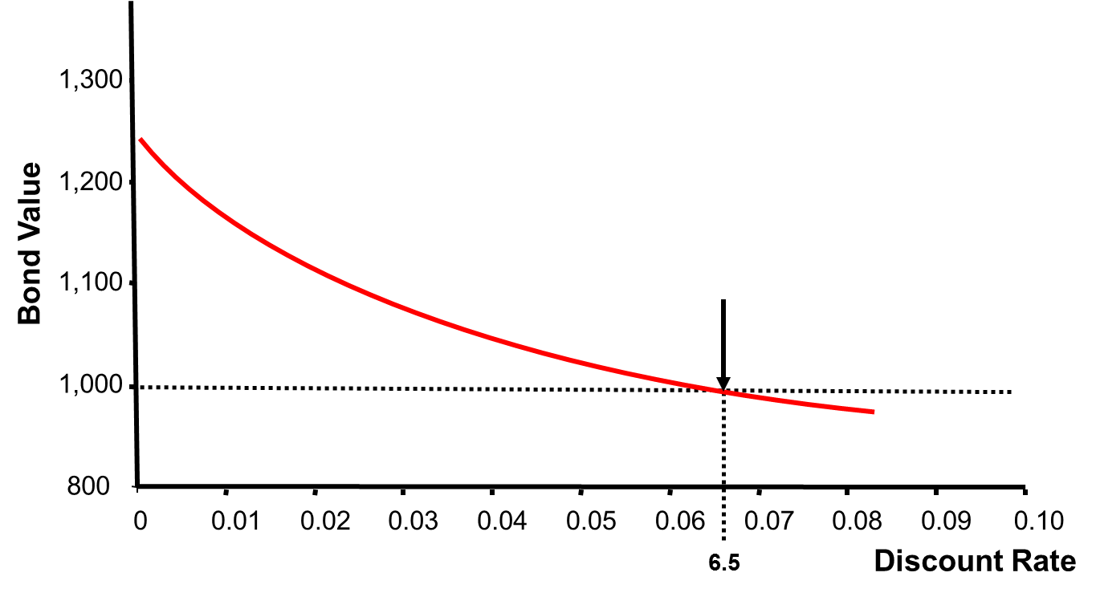

When the YTM < coupon rate, the bond trades at a _**premium**__

When the YTM = coupon, the bond trades at ___**par**____

When the YTM > coupon rate, the bond trades at a __**discount**____

1. Bond prices and interest rates move in **opposite directions** .

* When coupon rate > YTM, **price > par (premium)**
* When coupon rate = YTM, **price = par value**
* When coupon rate < YTM, **price < par value (discount)**

Which rate never changes for ordinary bonds? **Coupon rates**

1. Recall the bond value equation we previously covered for a bond with semi-annual coupon payments:



1. This graph demonstrates the relationship between time to maturity and bond value for premium, par value and discount bonds:

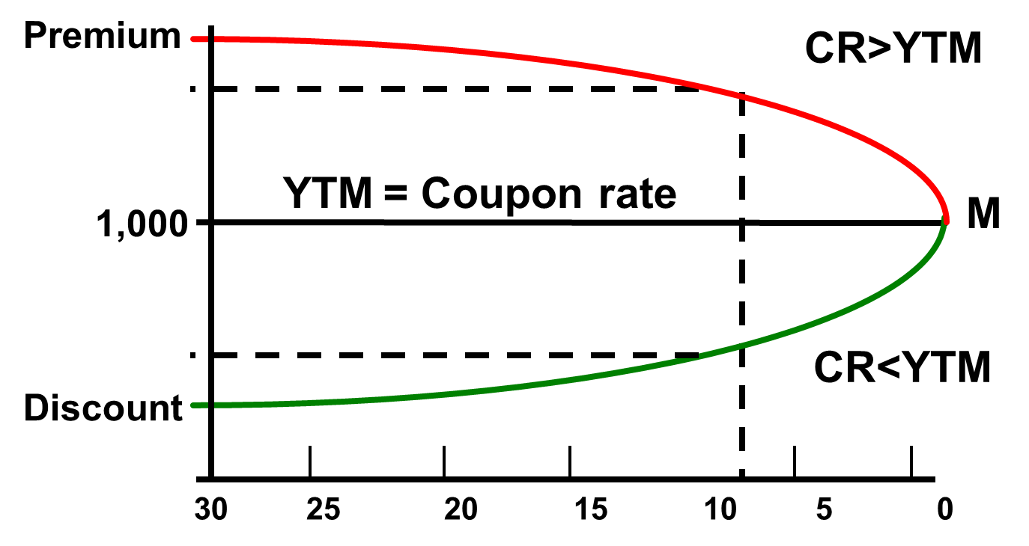

* What happens to the value (price) of a premium bond as it approaches maturity?
* What happens to the value (price of a discount bond as it approaches maturity?

1. Semiannual Bonds. Assume we have a bond with the following characteristics:
   * Coupon rate = 14% with semiannual payments
   * YTM = 16% (APR)
   * Maturity = 7 years
     1. Number of coupon payments? (2t or N): ____________________
     2. Semiannual coupon payment? (C/2 or PMT): _________________
     3. Semiannual yield? (YTM/2 or I/Y): ____________________
2. Pricing a semiannual bond:
   * Semiannual coupon = $70
   * Semiannual yield = 8%
   * Periods to maturity = 14

Using the calculator:

N = _________

I/Y = _________

PMT = ________

FV = __________

CPT PV = ___________

1. When you own bonds, you care about how interest rates affect bond prices.

* That is, you care about **interest rate risk**
* What is **Price Risk?**
* **Change in price due to change in interest rates price decrease as YTM increase**
  + Do long-term or short-term bonds have more price risk?
    - **Long-term bonds have more price risk than short term**
  + Do low or high coupon rate bonds have more price risk?
    - **Low coupon rate bonds have more price risk than high ones**
* What is **Reinvestment Rate Risk**?
  + **Uncertainty concerning rates at which cashflows can be revised**
* Obviously, this is more problematic when ____**interest rates fall**_____.
* Do long-term or short-term bonds have more reinvestment rate risk?
  + **Short term bonds have more reinvestment rate risk than long term**
* Do low or high coupon rate bonds have more reinvestment rate risk?
  + **High coupon rate bonds have more reinvestment rate risk than low ones**

1. Price Risk and Time to Maturity

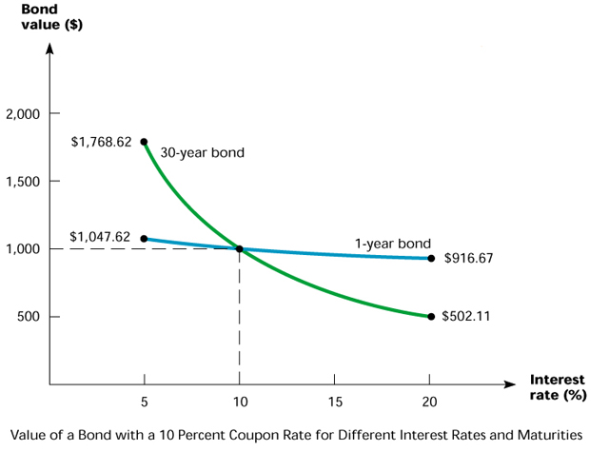

What does this figure demonstrate?

1. **Bond Rates and Yields**. Suppose a bond currently sells for $924.18. It pays an annual coupon of $80, and it matures in 5 years. It has a face value of $1000. What are its **coupon rate**, **current yield** and **yield to maturity (YTM)**?

* The **coupon rate** is the annual dollar coupon as a percentage of the face value:
* The **current yield** is the annual coupon divided by the current market price of the bond:
* The **yield to maturity** (or “**YTM**”) is the market required rate of return ***implied*** by the current bond price.
  + For each bond price, there is one YTM (all else equal).We can find **YTM** via trial and error or using our financial calculators:
  + Enter N, PV, PMT and FV—**Remember the sign convention!** 
    - PMT and FV need to have the same sign (+)
    - PV the opposite sign (-)
    - CPT I/Y for the yield
  + The **yield to maturity** is also the rate that makes the market price of the bond equal to the present value of its future cash flows. It is the unknown r in the equation below:

$924.18 = $80 × [1 - 1/(1 + *r*)5]/*r* + $1000/(1 + *r*)5

* + We can either find r via trial and error or using our financial calculators.
* PV =
* FV =
* PMT =
* N =
* I/Y =

1. **YTM with Annual Coupons**. Consider a bond with a 10% annual coupon rate, 15 years to maturity and a par value of $1,000. The current price is $928.09. Will the YTM be more than or less than 10%?

* N =
* PV =
* FV =
* PMT =
* I/Y =

1. **YTM with Semiannual Coupons**. Suppose a bond with a 10% coupon rate and **semiannual** coupons has a face value of $1,000, 20 years to maturity and is selling for $1,197.93.

* Is the YTM more or less than 10%?
* What is the semiannual coupon payment?
* How many periods are there?
  + PV =
  + FV =
  + PMT =
  + N =
  + I/Y =

Is the computed I/Y the YTM?

1. **Current Yield vs. Yield to Maturity**.

$$Current Yield=\frac{Annual Coupon Payment}{Current Price}$$

$$YTM=Current Yield+Capital Gains Yield$$

$$Capital Gains Yield=\% ∆ in Price$$

* Example: A 10% coupon bond, with semiannual coupons, face value of $1,000 and 20 years to maturity currently trades for $1,197.93

Current Yield =

Price in one year, assuming no change in YTM =

Capital Gains Yield =

YTM =

1. Debt versus Equity:

Debt

* + Not an ownership interest
  + No voting rights
  + Interest is tax-deductible
  + Creditors have legal recourse if interest or principal payments are missed
  + Excess debt can lead to financial distress and bankruptcy

Equity

* + Ownership interest
  + Common stockholders vote to elect the board of directors and on other issues
  + Dividends are not tax deductible
  + Dividends are not a liability of the firm until declared. Stockholders have no legal recourse if dividends are not declared
  + An all-equity firm cannot go bankrupt

1. What is a bond indenture? **Third party contract b/w bond issuer, bond holder, & the trustee**
2. In a bond indenture, the trustee is hired by the **issuer** to protect the

_**bondholder**_ interests.

1. The bond indenture includes the following six things:

* The basic terms of the bond issue
* The total amount of bonds issued
* A description of the security
* The repayment arrangements
* The call provisions
* Details of protective covenants

1. **Bond Indenture Features**. What is **Security**? **General term for assets pledged as security payment of debt**
2. What is meant by **Seniority**? **Preference in position over other lenders. #Senior or junior**
3. The terms of **Repayment** indicate whether the bonds are repaid at maturity or in part or entirely before maturity. What is a **sinking fund**? **Account managed by the bond trustee for the purpose of repaying the account**
4. What is the **Call Provision**? **Allows the company to repurchase or call part or all of the bond issued at a started price prior to maturity**
5. Define the **call premium**. **The amount in which the call price exceeds the par value of the bond**
6. What is the **deferred call provision**? **Prohibits the company from calling the bond prior to a certain date**
7. What is a **call-protected bond**? **Bond that cannot redeemed by issuer until certain date**
8. **Protective covenants** limit certain actions a company might otherwise wish to take during the term of the loan. There are two types: **negative covenants** and **positive covenants**.

* What is a **negative covenant**? **“thou shall not” 🡪issuing of long-term debt**
* What is a **positive covenant**? **“thou shall” 🡪 firm must maintain any collateral or security in good condition**

1. Bond Characteristics and Required Returns:

Coupon rate

* + ƒ(risk characteristics of the bond when issued)
  + Usually ≈ yield at issue

Which bonds will have the **higher** coupon, all else equal?

* + Secured debt versus a debenture = **secured**
  + Subordinated debenture versus senior debt **= subordinated**
  + A bond with a sinking fund versus one without = **without**
  + A callable bond versus a non-callable bond = **callable**

1. **Bond Ratings** indicate the ability of the borrower to repay the debt and are thus an indicator of default risk.

**Investment Quality Bonds:**

* High Grade:
  + Moody’s Aaa and S&P AAA – capacity to pay is __***Extremely Strong***
  + Moody’s Aa and S&P AA – capacity to pay is __***Very Strong***
* Medium Grade:
  + Moody’s A and S&P A – capacity to pay is strong, but more ___***Susceptible to chancges in circumsances***
  + Moody’s Baa and S&P BBB – capacity to pay is _***Adequete***__, adverse conditions will have more impact on the firm’s ability to pay

**Speculative Bonds:**

* **Low Grade or High Yield (i.e., “__*”JUNK”*_______” Bonds)**
  + Moody’s Ba and B
  + S&P BB and B
  + Considered __***Speculative***_____________ with respect to capacity to pay.
* **Very Low Grade**
  + Moody’s C and S&P C – income bonds with no interest being paid
  + Moody’s D and S&P D – in __***Default***_________ with principal and interest in arrears

1. U.S. Treasury Securities are described as whose debt?

***Federal Gov***

1. Who is the largest borrower in the world? How much is this borrower’s current total debt?

**Uncle Sam or US federal Gov 1.6Trillion**

1. ___***T-bills***_ are pure discount bonds with original maturity less than __***1yr***__.

___***T-notes***___ are coupon debt with original maturity between ___***1-10yrs***__.

___***T-bonds***___ are coupon debt with original maturity greater than __***10+ yrs***___.

1. Municipal Securities are described as whose debt?

**State and Local Gov**

* + What are we told about the default risk of municipal securities? Municipal securities are rated similar to what kind of debt?

***Varying degrees of default risk related similar to corporate debt***

* + What is special about the tax treatment of municipal securities?

***Interest received is tax-exempt at the fed lvl***

1. How many coupon payments are made on **zero coupon bonds**? What is the coupon rate?

***No coupon payments are made. Coupon rt = 0%***

* + On a zero coupon bond, the entire yield to maturity (YTM) comes from what?

***Comes from the differ btwn the purchase price and par value***

* + Cannot sell for more than ___***Par Value***____________
  + Sometimes called zeroes, deep discount bonds, or original issue discount bonds (OIDs)
  + __***Treasure Bills***___________________ and U.S. Savings bonds are good examples of zeroes.

1. **Pure Discount Bonds: Example**. Find the value of a 30-year zero-coupon bond with a $1000 par (face) value and a YTM of 6% using the above equation.

**PV = F / (1+r)^T 1000/(1.06)^30 = 174.11**

1. We can also solve the question above with the following calculator inputs:

* FV = 1000
* PMT = 0
* N = 30
* I/Y = 6
* PV = 174.11

1. Floating Rate Bonds
   * Coupon rate floats depending on some _***Index Value***___
   * Examples: ___***Adjustable Rt Mortgages and Inflation-linked Treasuries***___
   * Less __***Price***__ risk with floating rate bonds.
   * Coupons may have a “_***Collar***_”—the rate cannot go above a specified “__***Ceiling*** __” or below a specified “__***Floor***__”
2. **Bond Markets**.
   * Primarily ___***Over-the-Counter***___ transactions with dealers connected electronically.
   * Extremely large number of bond issues, but generally low daily volume in single issues.
   * Getting up-to-date prices difficult, particularly on small company or municipal issues.
   * ___***Treasury***___ securities are an exception.
3. __***Inflation***__ plays an important role in the determination of interest rates, yields and returns.

* ___***Real rts of Interest***___ are interest rates that have been adjusted for _***Inflation***__, which reflects change in purchasing power.
* __***Nominal rt of Interest***__ are interest rates that have **not** been adjusted for __***Inflation***_. These are the quoted interest rates, which reflect change in __***Purchasing power and Inflation***___

1. What is the **nominal rate** on an investment?

***The interest rate before taking inflation into account. Nominal can also refer to the advertised or stated interest rate on a loan, without considering any fees or compounding of interest.***

1. What is the **real rate** on an investment?

***an interest rate that has been adjusted to remove the effects of inflation to reflect the real cost of funds to the borrower and the real yield to the lender or to an investor.***

1. The **Fisher Effect** defines the relationship between real rates, nominal rates and inflation. State the Fisher Effect equation:

***(1+R) = (1+r)(1+h)***

R – nominal rt

r – Real rt

h = expected inflation rt

1. The approximation of the Fisher Effect equation is:

***R = r + h***

1. **The Fisher Effect: Example**. If we require a 10% real return and we expect inflation to be 8%, what is the nominal rate?
2. In general, the quoted (or nominal) interest rate on a debt security like a bond is composed of:

* The real risk-free rate, *r\**
* Plus several *premiums* reflecting inflation, the security’s default risk, its liquidity (or marketability), and the time to its maturity
* This relationship can be expressed as:

$$r=r^{*}+IP+DRP+LP+MRP$$

1. **Real risk-free rate (r*)**—the rate that would exist _on_**a riskless security in a world where no inflation was expected_**.
2. **Inflation Premium (IP)**—required return for __**expected inflation & is inrelated in the Quote (nominal) risk-free rate___**.
3. **Default Risk Premium** **(DRP)**—required return for __**higher risk to default__**.

* Bond ratings provide an indication of or measure _________________________.
* All else equal, the _________ the bond rating, the ___________ the default risk, and the ___________ the default risk premium.

1. **Liquidity premium (LP)** – return required for ________________________________.

* Bonds that have more frequent trading will generally have _________________

________________________________________________________________.

1. **Maturity Risk Premium (MRP)**– return required on bonds with ___________________

**______________________________**.

* Longer-term bonds are exposed to significant _______ risk associated with ____________ in interest rates and inflation

1. Anything else that affects the _______ of the ______ _________ to the bondholders will affect the required returns.